Author Guidelines for the   
British Machine Vision Conference Arial17

|  |  |
| --- | --- |
| Susan Student1  http://www.vision.inst.ac.uk/~ss  Petra Prof1  http://www.vision.inst.ac.uk/~pp  Colin Collaborator2  colin@collaborators.com | 1 The Vision Institute University of Borsetshire Wimbleham, UK  2 Collaborators, Inc. 123 Park Avenue, New York, USA |
|  |  |

**Abstract**

This document demonstrates the format requirements for papers submitted to the British Machine Vision Conference. The format is designed for easy on-screen reading, and to print well at one or two pages per sheet. Additional features include: pop-up annotations for citations [4, 6]; a margin ruler for reviewing; and a greatly simplified way of entering multiple authors and institutions.

**All authors are encouraged to read this document**, even if you have written many papers before. As well as a description of the format, the document contains many instructions relating to formatting problems and errors that are common even in the work of authors who have written many papers before. Times New Roman 9

1. Introduction (Times New Roman 16)

From 2009, the proceedings of BMVC (the British Machine Vision Conference) will be published only in electronic form. This document illustrates the required paper format, and includes guidelines on preparation of submissions. Papers which fail to adhere to these requirements may be rejected at any stage in the review process.

LATEX users should use this template in order to prepare their paper. Users of other packages should emulate the style and layout of this example. Note that best results will be achieved using pdflatex, which is available in most modern distributions.

By the way, this is Times New Roman 10.

* 1. Paper length (Times New Roman 12)

Paper length of the final version MUST not exceed 10 pages, *not counting* the bibliography. This is one page more than the version submitted for peer review. The extra page should give you the space to add author information, acknowledgments, and address reviewers’ comments.

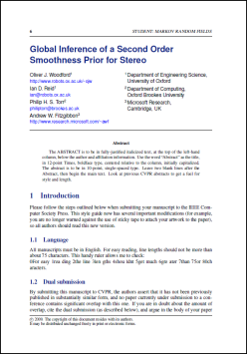 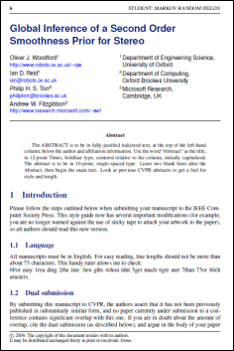 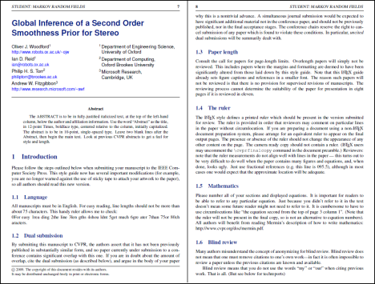

(a) (b) (c)

Figure 1: It is often a good idea for the first figure to attempt to encapsulate the article, complementing the abstract. This figure illustrates the various print and on-screen layouts for which this paper format has been optimized: (a) traditional BMVC print format; (b) on-screen single-column format, or large-print paper; (c) full-screen two column, or 2-up printing.

The bibliography should begin immediately after the paper text. It may be of any length, within reason. It should *not* include annotations, figures, or any other paraphernalia intended to subvert the paper length requirement.

* 1. Citations

When citing a multi-author paper, you may save space by using “*et alia*”, shortened to “et *al.*” (not “*et. al.*” as “et” is a complete word.) The provided \etal macro is a useful aide memoire in this regard. However, use it only when there are three or more authors. Thus, the following is correct: “ Frobnication has been trendy lately. It was introduced by Alpher [1], and subsequently developed by Alpher and Fotheringham-Smythe [2], and Alpher et *al.* [3].”

This is incorrect: “... subsequently developed by Alpher et *al.* [2] ...” because reference [2] has just two authors. If you use the \etal macro, then you need not worry about double periods when used at the end of a sentence as in Alpher et *al.*

We use natbib, so citations in random order are nicely sorted: [1, 2, 4, 5]. However, we don’t use the compress option, as we want each reference to have its own hyperlink and popup window.

* 1. Footnotes

Please use footnotes[1] sparingly. Indeed, try to avoid footnotes altogether and include necessary peripheral observations in the text (within parentheses, if you prefer, as in this sentence). If you wish to use a footnote, place it at the bottom of the column on the page on which it is referenced. Use Times 8-point type, single-spaced.

Figure 2: Example of a short caption, which should be centered.

|  |  |
| --- | --- |
| Method | Frobnability |
| Theirs | Frumpy |
| Yours | Frobbly |
| Ours | Makes one’s heart Frob |

Table 1: Results. Ours is better.

* 1. Mathematics

Please number all of your sections and displayed equations. It is important for readers to be able to refer to any particular equation. Just because you didn’t refer to it in the text doesn’t mean some future reader might not need to refer to it. It is cumbersome to have to use circumlocutions like “the equation second from the top of page 3 column 1”. (Note that the ruler will not be present in the final copy, so is not an alternative to equation numbers). All authors will benefit from reading Mermin’s description [6] of how to write mathematics.

* 1. References

List and number all bibliographical references in 9-point Times, single-spaced, at the end of your paper. When referenced in the text, enclose the citation number in square brackets, for example [4]. Where appropriate, include the name(s) of editors of referenced books.

* 1. Color

Color is valuable, and will be visible to readers of the electronic copy. However ensure that, when printed on a monochrome printer, no important information is lost by the conversion to grayscale.

References

[1] A. Alpher. Frobnication. *Journal of Foo*, 12(1):234–778, 2002.

[2] A. Alpher and J. P. N. Fotheringham-Smythe. Frobnication revisited. *Journal of Foo*, 13 (1):234–778, 2003.

[3] A. Alpher, J. P. N. Fotheringham-Smythe, and G. Gamow. Can a machine frobnicate? *Journal of Foo*, 14(1):234–778, 2004.

[4] Authors. The frobnicatable foo filter, 2006. ECCV06 submission ID 324. Supplied as additional material eccv06.pdf.

[5] Authors. Frobnication tutorial, 2006. Supplied as additional material tr.pdf.

[6] N. David Mermin. What’s wrong with these equations? *Physics Today*, October 1989. http://www.cvpr.org/doc/mermin.pdf.

1. Notes for Microsoft Word (or other .doc*) users
   1. Converting to PDF

When printing this document or converting to PDF, it appears that some word processors have problems with the custom page size of 14.4cm x 21.8cm. The output might be of A4 paper size with the smaller text centred on top. One solution to this problem is to generate the PDF as usual and later cropping the excess borders with a post processing tool. Some free PDF writers include this post processing option to crop the paper of the final output.

1. This is what a footnote looks like. It often distracts the reader from the main flow of the argument.